**Physical Identification of Major Components**

1. **CPU**

CPU stands for Central Processing Unit, and it is often referred to as the "brain" of the computer. The CPU is a critical component responsible for executing instructions from computer programs, performing calculations, and managing data flow within the system.

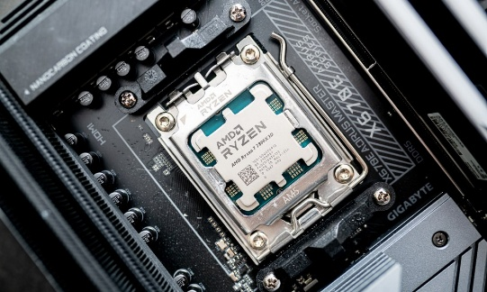**1.Functions of the CPU**

* **Instruction Execution**: The CPU processes instructions from software applications and the operating system. It fetches, decodes, and executes these instructions in a sequence.
* **Arithmetic and Logic Operations**: The CPU performs basic arithmetic operations (addition, subtraction, multiplication, division) and logical operations (comparisons, Boolean operations) using its Arithmetic Logic Unit (ALU).
* **Control Operations**: The CPU manages the flow of data between the various components of the computer, including memory (RAM), storage devices, and input/output devices. It uses control signals to coordinate these operations.

**2. Components of the CPU**

* **ALU (Arithmetic Logic Unit)**: This part of the CPU performs all arithmetic and logical operations.
* **Control Unit (CU)**: The control unit directs the operation of the processor. It tells the ALU what operation to perform and manages the flow of data within the CPU and to other components.
* **Registers**: These are small, high-speed storage locations within the CPU that temporarily hold data and instructions that are being processed. Common registers include the accumulator, instruction register, and program counter.
* **Cache Memory**: CPUs often have multiple levels of cache (L1, L2, L3) that provide faster access to frequently used data and instructions, reducing the time it takes to fetch data from the main memory (RAM).

**3. Types of CPUs**

* **Single-Core CPUs**: These have one processing unit and can execute one instruction at a time.
* **Multi-Core CPUs**: These have multiple processing units (cores) on a single chip, allowing them to execute multiple instructions simultaneously. Common configurations include dual-core, quad-core, and octa-core processors.
* **Specialized CPUs**: Some CPUs are designed for specific tasks, such as Graphics Processing Units (GPUs) for rendering graphics or Digital Signal Processors (DSPs) for processing audio and video signals.

**2.Motherboard**

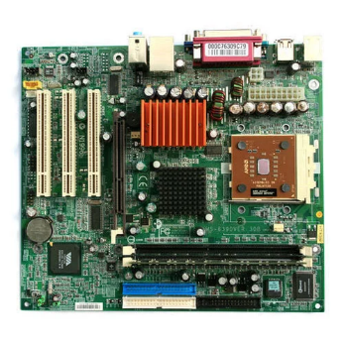The motherboard is the central hub of a computer, serving as the main printed circuit board (PCB) that connects all components and peripherals. It is typically a rectangular board that houses critical features such as the CPU socket, where the processor is installed, and RAM slots for memory modules. Additionally, the motherboard includes expansion slots (like PCIe) for adding graphics cards or other peripherals, power connectors for the power supply unit (PSU), and various I/O ports (USB, HDMI, Ethernet) for external device connectivity. Specifications for motherboards vary widely, with different form factors (such as ATX, Micro-ATX, and Mini-ITX) and chipset models (e.g., Intel Z490, AMD B550) that determine compatibility with processors and memory types. Understanding the motherboard's layout and specifications is crucial for building or upgrading a computer system.

**3.RAM Modules**

Random Access Memory (RAM) is a vital component that acts as the computer's short-term memory, temporarily storing data that the CPU needs to access quickly. RAM modules are typically long, thin sticks with gold connectors that fit into the motherboard's RAM slots. They come in various types, including DDR3, DDR4, and DDR5, each with different performance characteristics. The specifications of RAM include capacity (ranging from 4GB to 32GB or more), speed (measured in MHz, such as 2400MHz or 3200MHz), and latency (CAS latency, e.g., CL16). The amount and speed of RAM directly impact a computer's performance, especially in multitasking and memory-intensive applications.

**4.Daughter Cards**

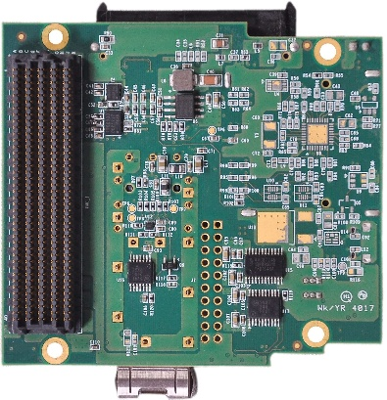Daughter cards are additional circuit boards that connect to the motherboard to enhance the computer's functionality. Common examples include graphics cards (GPUs), sound cards, and network interface cards (NICs). These cards are typically installed in the motherboard's PCIe slots, allowing for high-speed data transfer. The specifications of daughter cards vary based on their purpose; for instance, a graphics card may have dedicated memory (e.g., 4GB or 8GB of VRAM) and a specific clock speed (e.g., 1500MHz). Understanding the role of daughter cards is essential for optimizing a computer's performance for specific tasks, such as gaming or professional graphics work.

**5.Bus Slots**

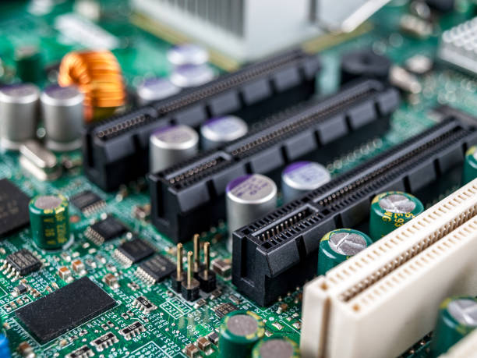

Bus slots are connectors on the motherboard that allow for the installation of expansion cards, enabling the addition of new functionalities to the computer. The most common types of bus slots are PCIe (Peripheral Component Interconnect Express) and PCI (Peripheral Component Interconnect). These slots vary in size and configuration, with PCIe slots available in different lane counts (e.g., x1, x4, x8, x16), which determine the bandwidth available for data transfer. Understanding bus slots is crucial for selecting compatible expansion cards and ensuring optimal performance.

**6.SMPS (Switched-Mode Power Supply)**

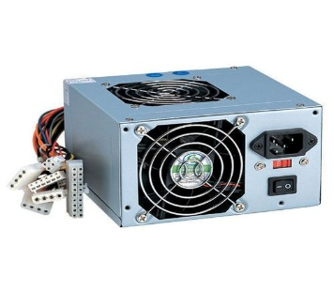

The Switched-Mode Power Supply (SMPS) is a critical component that converts alternating current (AC) from the wall outlet into direct current (DC) used by the computer's internal components. The SMPS is typically housed in a metal box located at the back of the computer case and features various power connectors for the motherboard, CPU, and peripherals. Specifications for SMPS units include wattage (e.g., 500W, 750W) and efficiency ratings (e.g., 80 Plus Bronze, Silver, Gold), which indicate how effectively the power supply converts power and how much energy is wasted as heat. A reliable SMPS is essential for stable system performance and longevity.

**7.Internal Storage Devices**

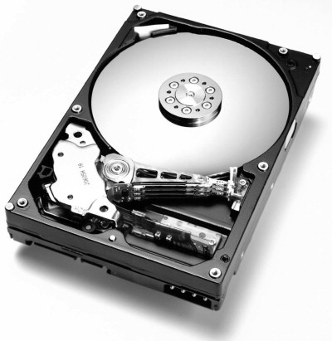Internal storage devices are used to store data permanently, and they come in two primary types: Hard Disk Drives (HDDs) and Solid State Drives (SSDs). HDDs are larger and heavier, utilizing spinning disks to read and write data, while SSDs are smaller, lighter, and faster, using flash memory with no moving parts. The specifications of these storage devices include capacity (ranging from 256GB to several terabytes), interface type (SATA for HDDs and SSDs, NVMe for high-speed SSDs), and form factor (2.5-inch for HDDs/SSDs, M.2 for SSDs). The choice between HDDs and SSDs significantly impacts a computer's speed, boot time, and overall performance.

**8.Interfacing Ports**

Interfacing ports are essential for connecting external devices to the computer, allowing for communication and data transfer between the computer and peripherals. These ports come in various types, each serving a specific purpose. Common interfacing ports include USB (Universal Serial Bus), HDMI (High-Definition Multimedia Interface), Ethernet, and audio jacks.

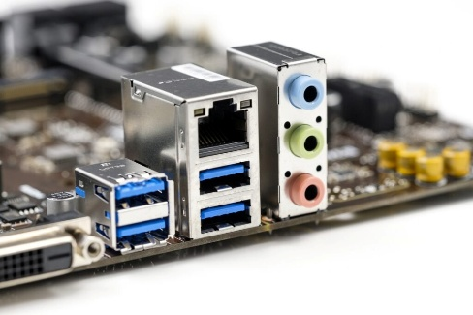

* **USB Ports**: These are versatile and can connect a wide range of devices, such as keyboards, mice, printers, and external storage drives. USB ports come in different versions, including USB 2.0, USB 3.0, and USB-C, each offering varying data transfer speeds and capabilities.
* **HDMI Ports**: HDMI ports are used for transmitting high-definition video and audio signals to monitors, TVs, and projectors. They support high-quality video formats and are essential for multimedia applications.
* **Ethernet Ports**: These ports enable wired network connections, allowing the computer to connect to local area networks (LAN) and access the internet. Ethernet ports are crucial for stable and high-speed internet connectivity, especially in environments where wireless connections may be unreliable.
* **Audio Jacks**: Audio jacks allow for the connection of speakers, headphones, and microphones. They are typically color-coded (green for audio output, pink for microphone input) and are essential for multimedia applications, gaming, and communication.